**SAVEETHA SCHOOL OF ENGINEERING,THANDALAM**

**COMPUTER VISION WITH OPEN CV**

**NAME: S.PADMASRI**

**REG.NO:192124165**

**SUB CODE: DSA0203**

**PROGRAM 1:**

**Perform basic Image Handling and processing operations on the image. • Read an image in python and Convert an Image to Grayscale .**

**AIM:**

**To Perform Basic Operations to Read Image and Convert to Grayscale using Python.**

**PROGRAM:**

**import cv2**

**import numpy as np**

**kernel = np.ones((5,5),np.uint8)**

**print(kernel)**

**path = r"C:\Users\PADMASRI\Downloads\pic.jpeg"**

**img =cv2.imread(path)**

**imgGray = cv2.cvtColor(img,cv2.COLOR_BGR2GRAY)**

**cv2.imshow("GrayScale",imgGray)**

**cv2.waitKey(0)**

**INPUT:**



**OUTPUT:**

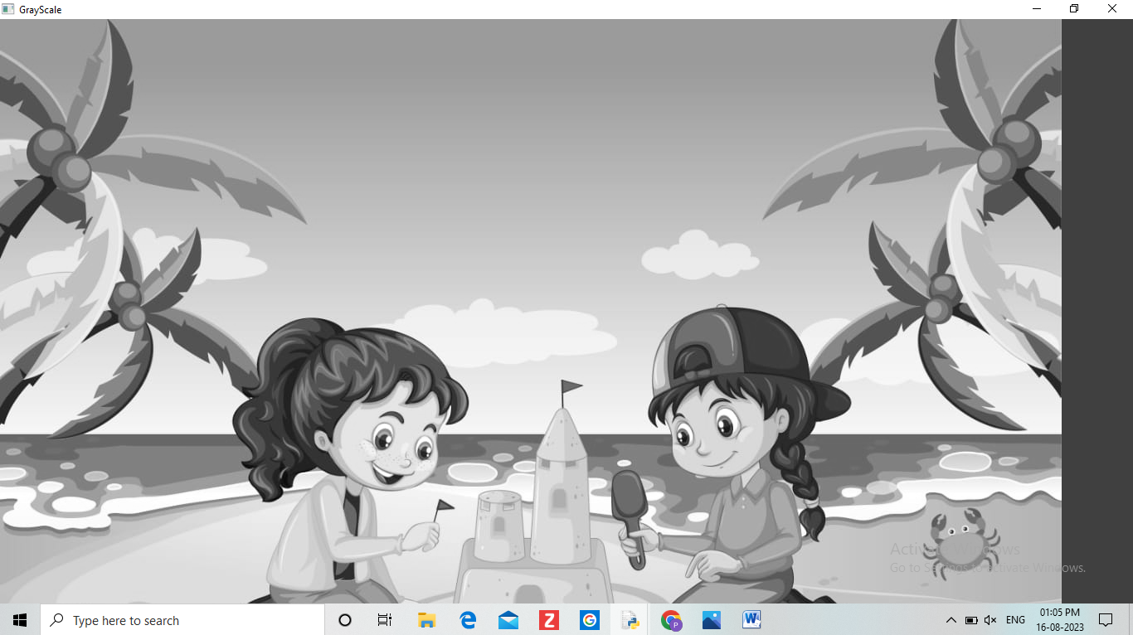

PROGRAM 2:

**Perform basic Image Handling and processing operations on the image.• Read an image in python and Convert an Image to Blur using GaussianBlur**

AIM:

**To Perform Basic Operations to Read Image and Convert to Blur using GaussianBlur.**

PROGRAM:

**import cv2**

**import numpy as np**

**kernel = np.ones((5,5),np.uint8)**

**print(kernel)**

**path = r"C:\Users\PADMASRI\Downloads\rose.jpeg"**

**img =cv2.imread(path)**

**imgGray = cv2.cvtColor(img,cv2.COLOR_BGR2GRAY)**

**imgBlur = cv2.GaussianBlur(imgGray,(7,7),0)**

**cv2.imshow("Img Blur",imgBlur)**

**cv2.waitKey(0**)

INPUT:

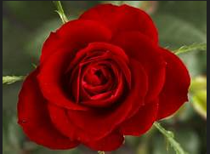

OUTPUT:

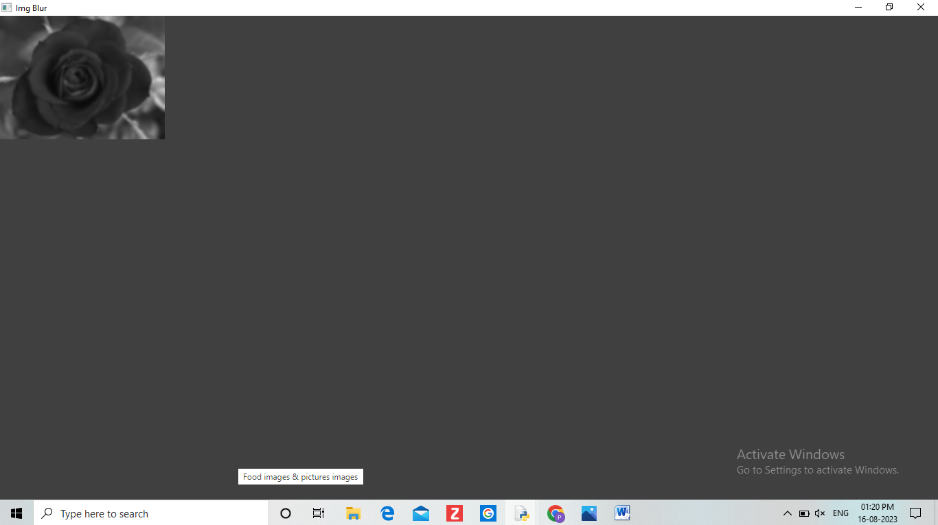

PROGRAM 3:

**Perform basic Image Handling and processing operations on the image• Read an image in python and Convert an Image to show outline using Canny function**

AIM:

**To Perform Basic Operations to Convert image to show outline Canny function in Python**

PROGRAM:

**import cv2**

**import numpy as np**

**kernel = np.ones((5,5),np.uint8)**

**print(kernel)**

**path = r"C:\Users\PADMASRI\Downloads\pic.jpeg"**

**img =cv2.imread(path)**

**imgGray = cv2.cvtColor(img,cv2.COLOR_BGR2GRAY)**

**imgBlur = cv2.GaussianBlur(imgGray,(7,7),0)**

**imgCanny = cv2.Canny(imgBlur,100,200)**

**cv2.imshow("Img Canny",imgCanny)**

**cv2.waitKey(0)**

INPUT:



OUTPUT:

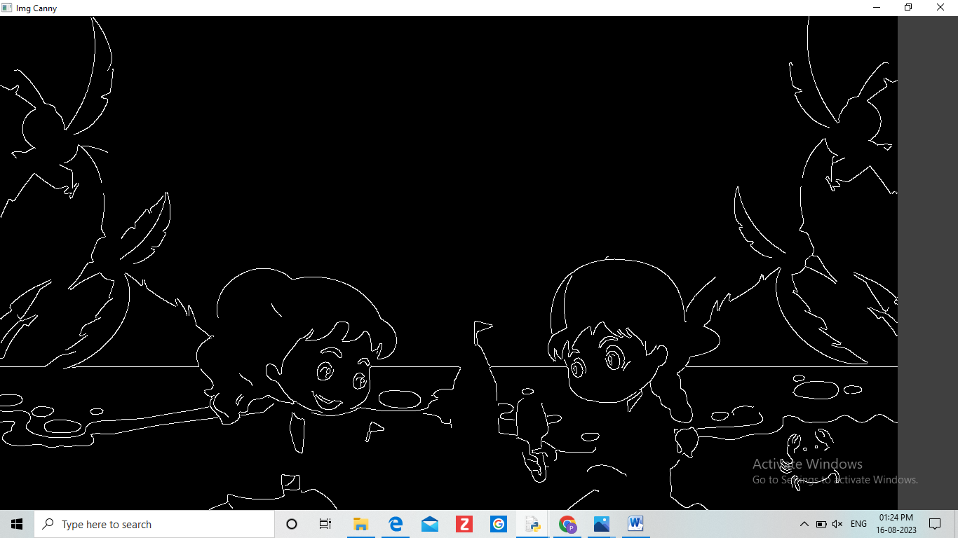

PROGRAM 4:

**Perform basic Image Handling and processing operations on the image• Read an image in python and Dilate an Image using Dilate function**

AIM:

**To Perform Basic Operations to Read Image and Dilate an Image using Python**

PROGRAM:

**import cv2**

**import numpy as np**

**kernel = np.ones((5,5),np.uint8)**

**print(kernel)**

**path = r"C:\Users\PADMASRI\Downloads\rose.jpeg"**

**img =cv2.imread(path)**

**imgGray = cv2.cvtColor(img,cv2.COLOR_BGR2GRAY)**

**imgBlur = cv2.GaussianBlur(imgGray,(7,7),0)**

**imgCanny = cv2.Canny(imgBlur,100,200)**

**imgDilation = cv2.dilate(imgCanny,kernel , iterations = 10)**

**imgEroded = cv2.erode(imgDilation,kernel,iterations=2)**

**cv2.imshow("Img Erosion",imgEroded)**

**cv2.waitKey(0)**

INPUT:



OUTPUT:

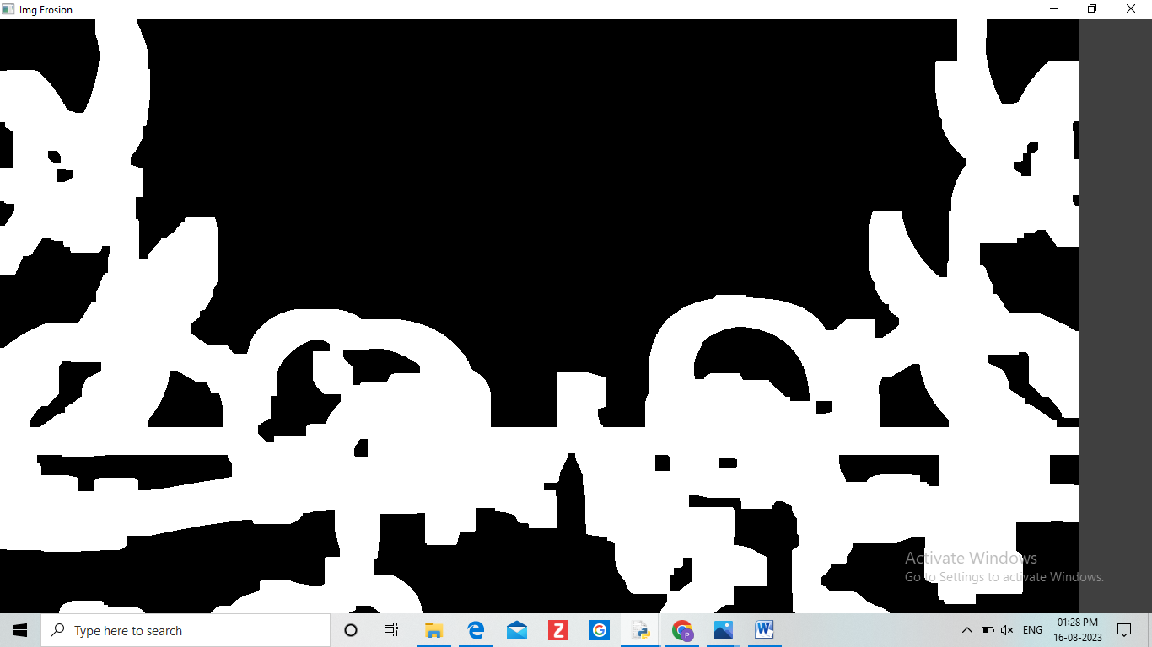

PROGRAM 5:

**Perform basic Image Handling and processing operations on the image• Read an image in python and Erode an Image using erode function**

AIM:

**The Aim of the experiment is to Read an image in python and Erode an Image using erode function**

PROGRAM:

**import cv2**

**import numpy as np**

**kernel = np.ones((5,5),np.uint8)**

**print(kernel)**

**path = r"C:\Users\PADMASRI\Downloads\rose.jpeg"**

**img =cv2.imread(path)**

**imgGray = cv2.cvtColor(img,cv2.COLOR_BGR2GRAY)**

**imgBlur = cv2.GaussianBlur(imgGray,(7,7),0)**

**imgCanny = cv2.Canny(imgBlur,100,200)**

**imgDilation = cv2.dilate(imgCanny,kernel , iterations = 10)**

**imgEroded = cv2.erode(imgDilation,kernel,iterations=2)**

**cv2.imshow("Img Erosion",imgEroded)**

**cv2.waitKey(0)**

INPUT:



OUTPUT:

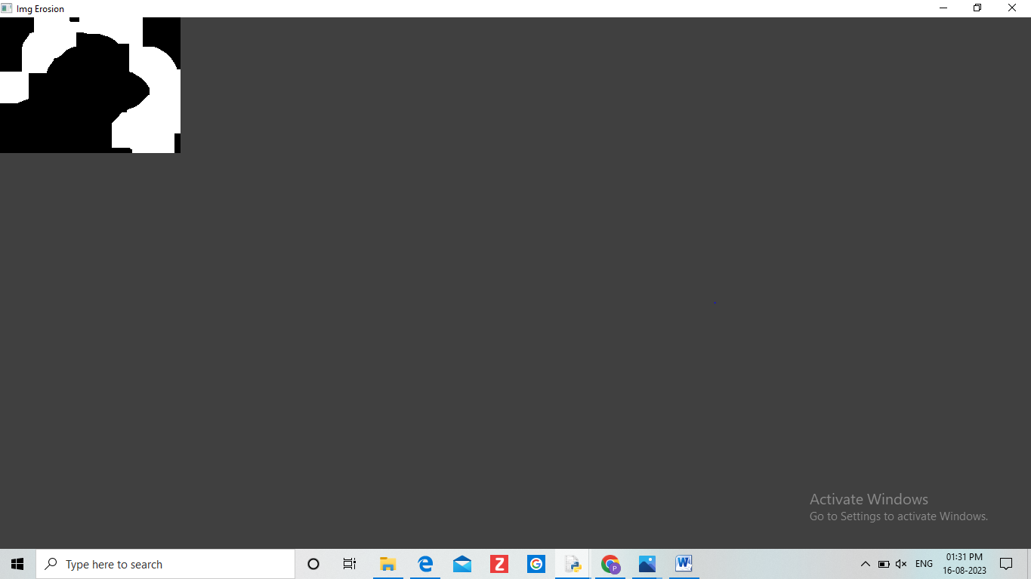

**PROGRAM 6:**

**Perform basic video processing operations on the captured video• Read captured video in python and display the video, in slow motion and in fast motion.**

**AIM:**

**The Aim of the Experiment is to Read captured video in python and display the video, in slow motion and in fast motion.**

**PROGRAM:**

**import cv2**

**import numpy as np**

**cap = cv2.VideoCapture(r"C:\Users\PADMASRI\Downloads\birds.mp4")**

**if (cap.isOpened()== False):**

**print("Error opening video file")**

**while(cap.isOpened()):**

**ret, frame = cap.read()**

**if ret == True:**

**cv2.imshow('Frame', frame)**

**if cv2.waitKey(250) & 0xFF == ord('q'):**

**break**

**else:**

**break**

**cap.release()**

**cv2.destroyAllWindows()**

**INPUT:**

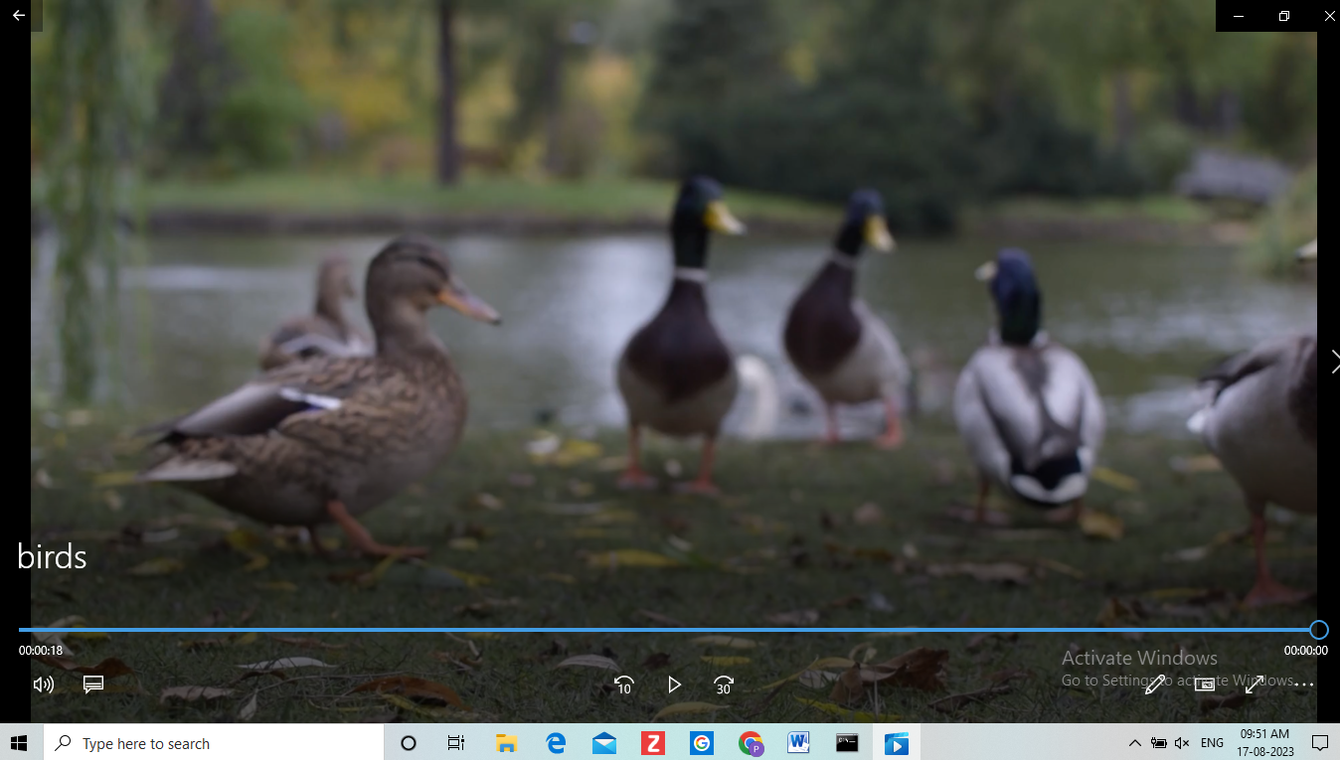

**OUTPUT:**

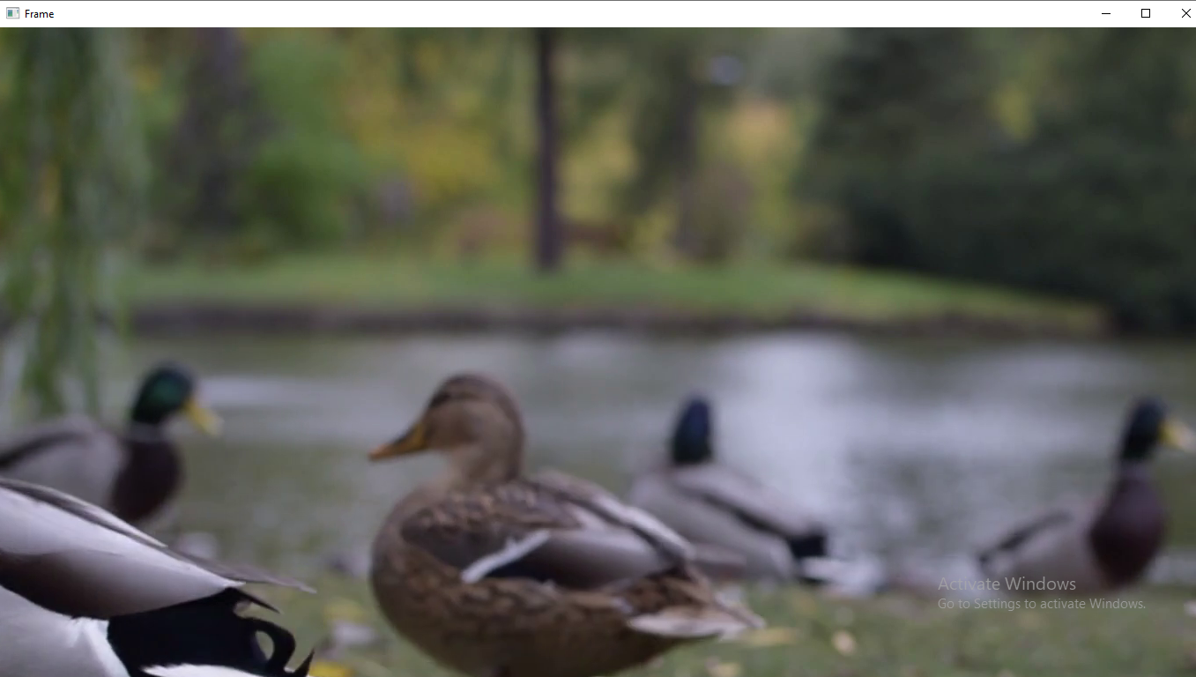

**PROGRAM 7:**

**Capture video from web Camera and Display the video, in slow motion and in fast motion operations on the captured video.**

**AIM:**

**The Aim is to Capture video from web Camera and Display the video, in slow motion and in fast motion operations on the captured video.**

**PROGRAM:**

**import cv2**

**cap = cv2.VideoCapture(0)**

**height = int(cap.get(cv2.CAP_PROP_FRAME_HEIGHT))**

**width = int(cap.get(cv2.CAP_PROP_FRAME_WIDTH))**

**fps = cap.get(cv2.CAP_PROP_FPS)**

**path = "0"**

**fourcc = cv2.VideoWriter_fourcc(*'mp4v')**

**output = cv2.VideoWriter(path, fourcc, 2,(width, height))**

**while True:**

**ret, frame = cap.read()**

**cv2.imshow("frame", frame)**

**output.write(frame)**

**k = cv2.waitKey(24)**

**if k == ord("q"):**

**break**

**cap.release()**

**output.release()**

**cv2.destroyAllWindows()**

**OUTPUT:**

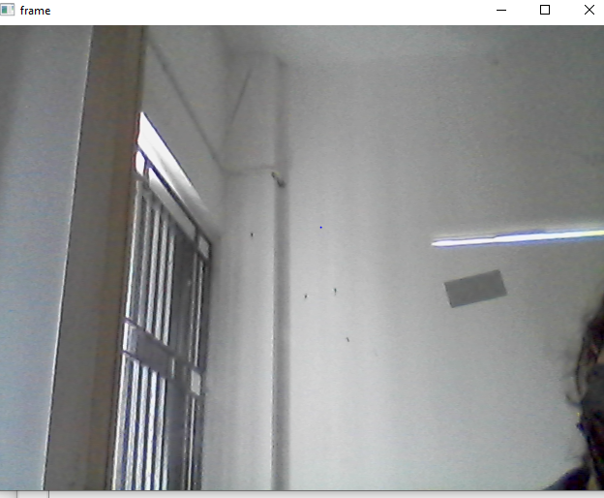

**PROGRAM 8:**

**Scaling an image to its Bigger and Smaller sizes.**

**AIM:**

**The Aim is resize the image from bigger to smaller size.**

**PROGRAM:**

**import cv2**

**import numpy as np**

**kernel = np.ones((5,5),np.uint8)**

**print(kernel)**

**path = r"C:\Users\PADMASRI\Downloads\rose.jpeg"**

**img =cv2.imread(path)**

**imgGray = cv2.cvtColor(img,cv2.COLOR_BGR2GRAY)**

**imgBlur = cv2.GaussianBlur(imgGray,(7,7),0)**

**imgCanny = cv2.Canny(imgBlur,100,200)**

**cv2.imshow("Img Canny",imgCanny)**

**cv2.waitKey(0)**

**INPUT:**



**OUTPUT:**

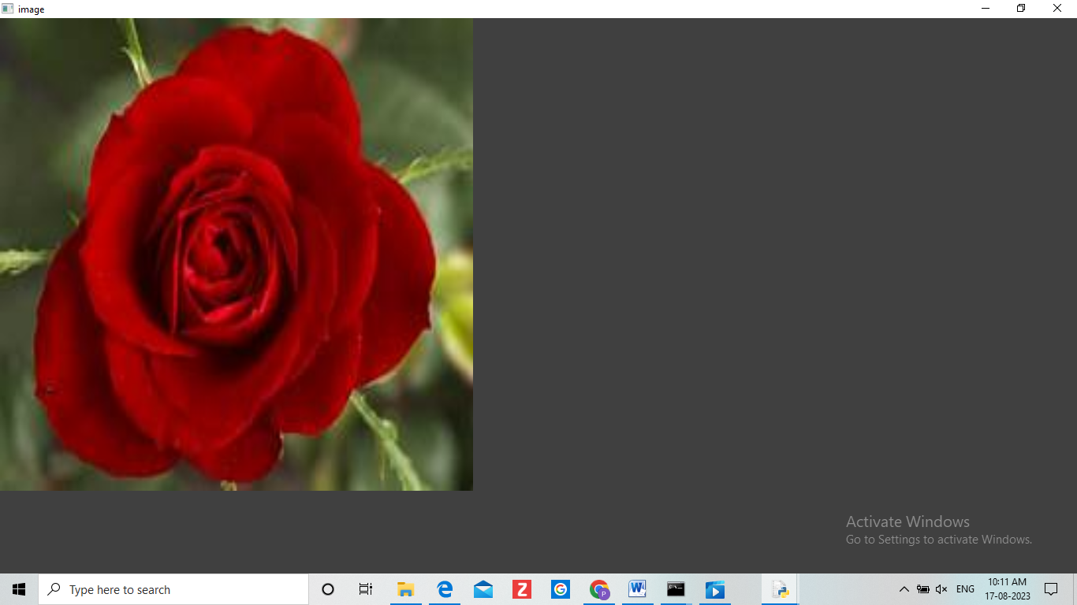

**PROGRAM 9:**

**ROTATION 90 ALONG DEGREE:**

**AIM:**

**The Aim of the Experiment is to perform Rotation of an image along 90 degree**

**PROGRAM:**

**import cv2**

**path=r"C:\Users\PADMASRI\Downloads\pic.jpeg"**

**src = cv2.imread(path)**

**window_name = 'Image'**

**image = cv2.rotate(src, cv2.ROTATE_180)**

**cv2.imshow(window_name, image)**

**cv2.waitKey(0)**

**INPUT:**



**OUTPUT:**

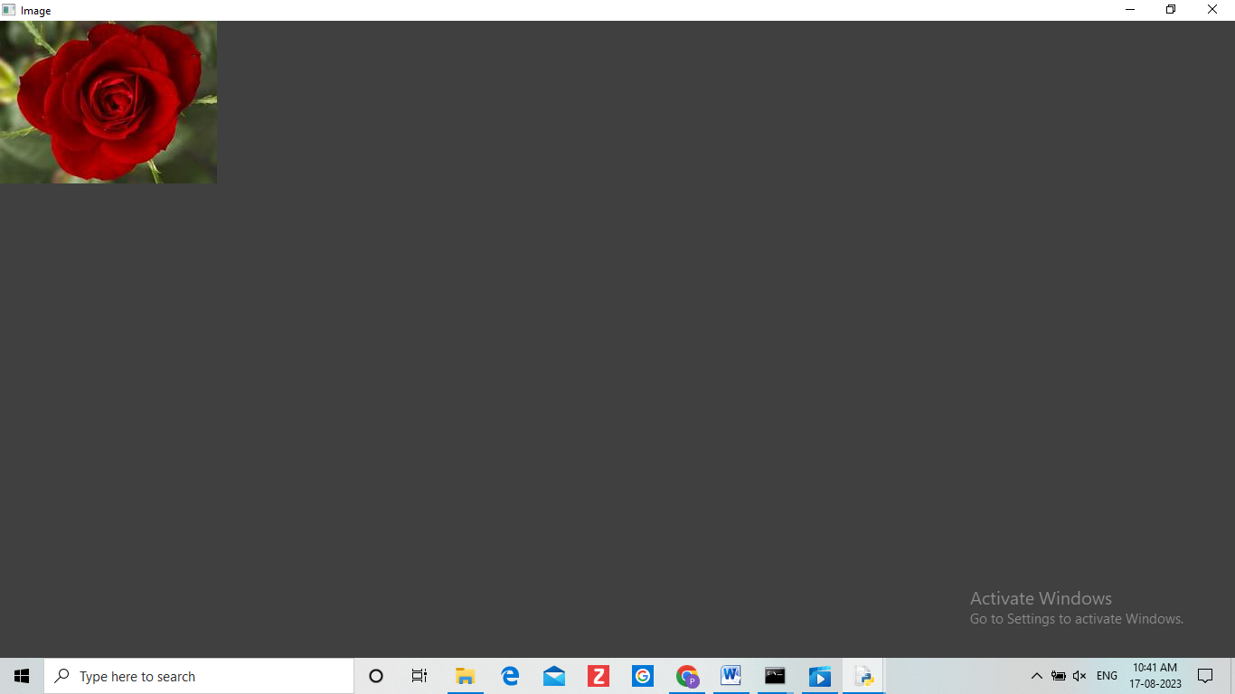

**PROGRAM 10:**

**ROTATION ALONG 180 DEGREE**

**AIM:**

**The Aim of the Experiment is to perform Rotation of an image along 180 degree.**

**PROGRAM:**

**INPUT:**



**OUTPUT:**

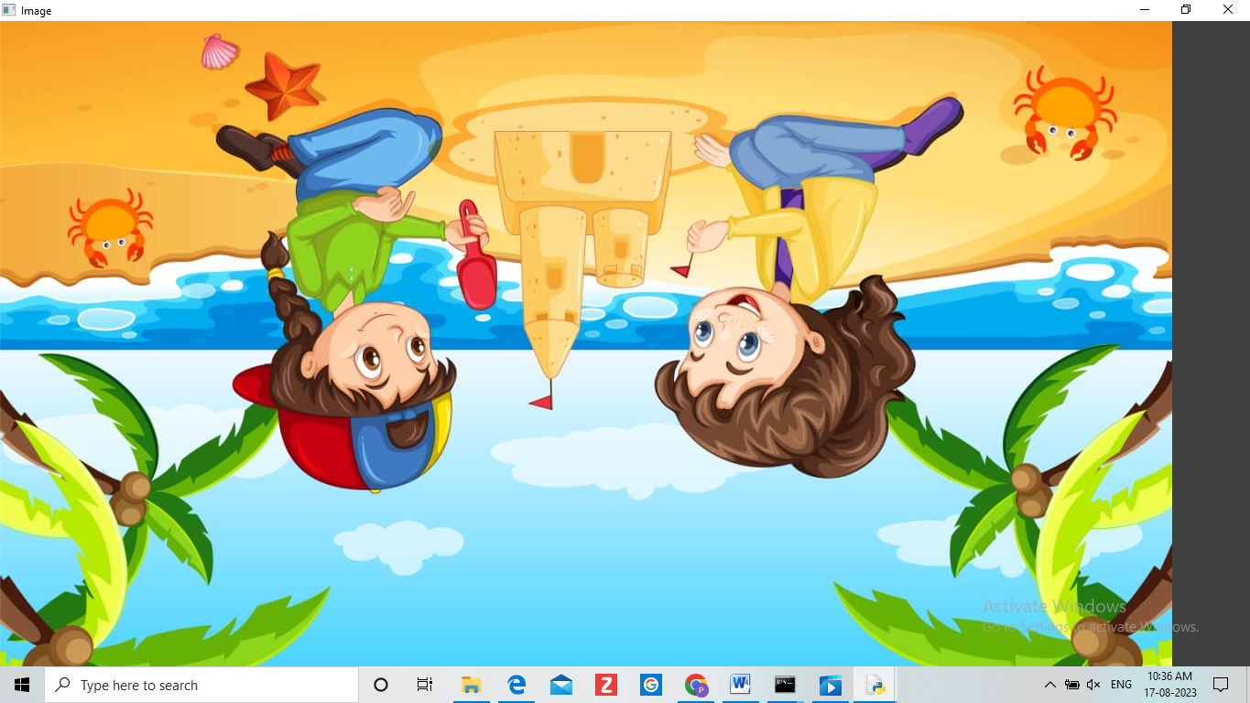

**ROTATION ALONG 270 DEGREE.**

**AIM:**

**The Aim of the Experiment is to perform Rotation of an image along 270 degree.**

**PROGRAM:**

**import cv2**

**path = r"C:\Users\PADMASRI\Downloads\pic.jpeg"**

**src = cv2.imread(path)**

**window_name = 'Image'**

**image = cv2.rotate(src, cv2.ROTATE_90_COUNTERCLOCKWISE)**

**cv2.imshow(window_name, image)**

**cv2.waitKey(0)**

**INPUT:**



**OUTPUT:**

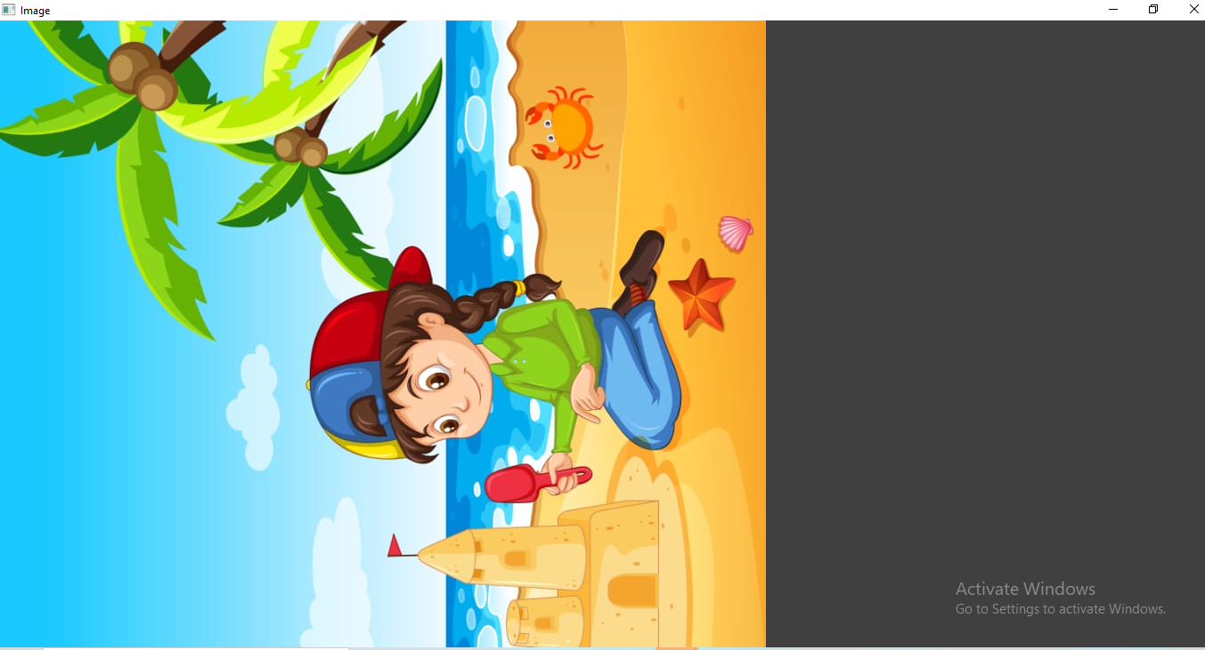

**PROGRAM 11:**

**Perform Affine Transformation on the image**

**AIM:**

**The aim of this experiment is to perform affine transformation on the image.**

**PROGRAM:**

**import cv2**

**import numpy as np**

**img = cv2.imread(r"C:\Users\PADMASRI\Downloads\pic.jpeg")**

**rows,cols,_ = img.shape**

**pts1 = np.float32([[50,50],[200,50],[50,200]])**

**pts2 = np.float32([[10,100],[200,50],[100,250]])**

**M = cv2.getAffineTransform(pts1,pts2)**

**dst = cv2.warpAffine(img,M,(cols,rows))**

**cv2.imshow("Affine Transform", dst)**

**cv2.waitKey(0)**

**cv2.destroyAllWindows()**

**INPUT:**



**OUTPUT:**

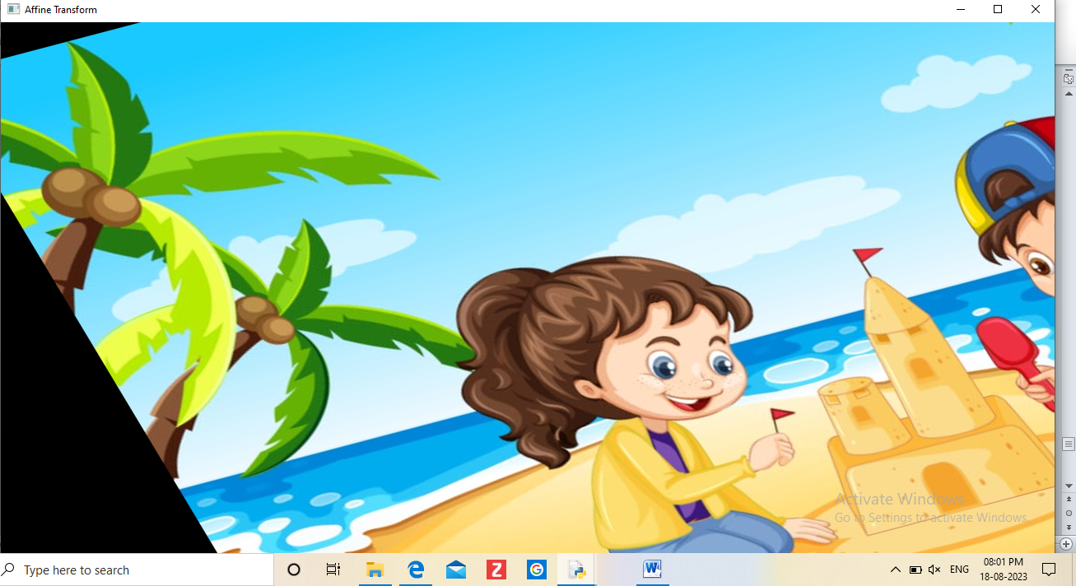

**PROGRAM 12:**

**Perform Perspective Transformation on the image.**

**AIM:**

**The aim of the experiment is to perform perspective transformation on the image.**

**PROGRAM:**

**import cv2**

**import numpy as np**

**img = cv2.imread(r"C:\Users\PADMASRI\Downloads\rose.jpeg")**

**rows,cols,ch = img.shape**

**# define four points on input image**

**pts1 = np.float32([[56,65],[368,52],[28,387],[389,390]])**

**# define the corresponding four points on output image**

**pts2 = np.float32([[100,50],[300,0],[0,300],[300,300]])**

**# get the perspective transform matrix**

**M = cv2.getPerspectiveTransform(pts1,pts2)**

**# transform the image using perspective transform matrix**

**dst = cv2.warpPerspective(img,M,(cols, rows))**

**# display the transformed image**

**cv2.imshow('Transformed Image', dst)**

**cv2.waitKey(0)**

**cv2.destroyAllWindows()**

**INPUT:**



**OUTPUT:**

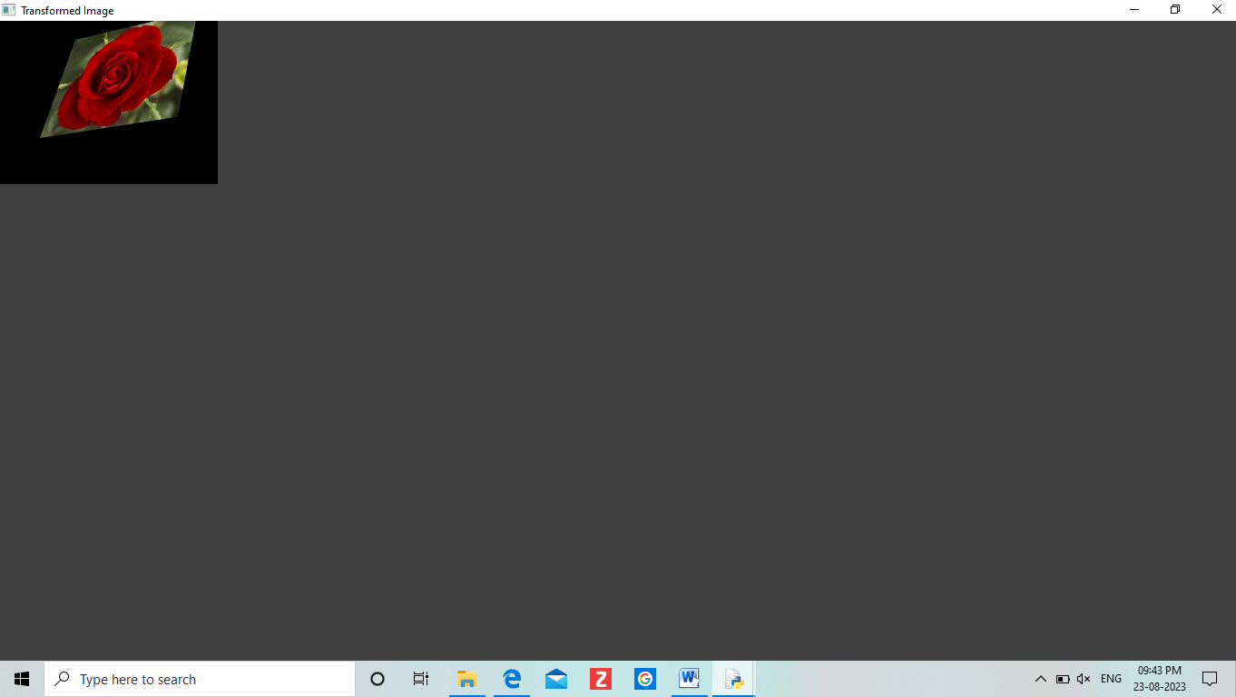

**PROGRAM 13:**

**Perform Perspective Transformation on the Video**

**AIM:**

**To Perform Perspective Transformation on the Video.**

**PROGRAM:**

**import cv2**

**import numpy as np**

**cap = cv2.VideoCapture(r"C:\Users\PADMASRI\Downloads\bird.mp4")**

**while True:**

**ret, frame = cap.read()**

**pts1 = np.float32([[200,300], [5, 2],**

**[0, 4], [6, 0]])**

**pts2 = np.float32([[0, 0], [4, 0],**

**[0, 1], [4, 6]])**

**matrix = cv2.getPerspectiveTransform(pts1, pts2)**

**result = cv2.warpPerspective(frame, matrix, (0, 0))**

**cv2.imshow('frame', frame) # Initial Capture**

**cv2.imshow('frame1', result) # Transformed Capture**

**if cv2.waitKey(24)== 27:**

**break**

**cap.release()**

**cv2.destroyAllWindows()**

**PROGRAM 14:**

**Perform transformation using Homography matrix**

**AIM:**

**To Perform transformation using Homography matrix**

**PROGRAM:**

**import cv2**

**import numpy as np**

**im_src = cv2.imread(r"C:\Users\PADMASRI\Downloads\rose.jpeg")**

**pts_src = np.array([[141, 131], [480, 159], [493, 630],[64, 601]])**

**im_dst = cv2.imread(r"C:\Users\PADMASRI\Downloads\rose.jpeg")**

**pts_dst = np.array([[318, 256],[534, 372],[316, 670],[73, 473]])**

**h, status = cv2.findHomography(pts_src, pts_dst)**

**im_out = cv2.warpPerspective(im_src, h, (im_dst.shape[1],im_dst.shape[0]))**

**cv2.imshow("Source Image", im_src)**

**cv2.imshow("Destination Image", im_dst)**

**cv2.imshow("Warped Source Image", im_out)**

**cv2.waitKey(0)**

**INPUT:**



**OUTPUT:**

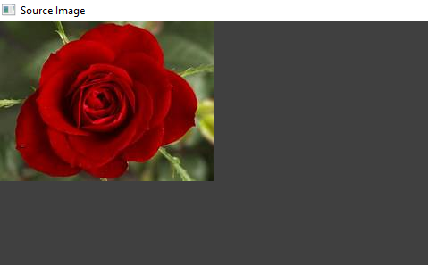

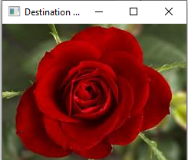

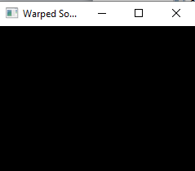

**PROGRAM 15:**

**Perform transformation using Direct Linear Transformation**

**AIM:**

**To Perform transformation using Direct Linear Transformation**

**PROGRAM:**

**import cv2**

**import numpy as np**

**# Load images**

**img1 = cv2.imread("C:/Users/PADMASRI/Download/pic.jpeg")**

**img2 = cv2.imread("C:/Users/PADMASRI/Download/rose.jpeg")**

**# Define corresponding points**

**pts1 = np.array([[50, 50], [200, 50], [50, 200], [200, 200]])**

**pts2 = np.array([[100, 100], [300, 100], [100, 300], [300, 300]])**

**# Estimate projective transformation matrix using DLT**

**H, _ = cv2.findHomography(pts1, pts2)**

**# Apply projective transformation to img1**

**dst = cv2.warpPerspective(img1, H, (img2.shape[1], img2.shape[0]))**

**# Display images**

**cv2.imshow('img1', img1)**

**cv2.imshow('img2', img2)**

**cv2.imshow('dst', dst)**

**cv2.waitKey(0)**

**cv2.destroyAllWindows()**

**PROGRAM 16:**

Perform Edge detection using canny method.

**AIM:**

To Perform Edge detection using canny method

**PROGRAM:**

**import cv2**

**img = cv2.imread("C:/Users/PADMASRI/Downloads/pic.jpeg")**

**cv2.imshow('Original', img)**

**cv2.waitKey(0)**

**img_gray = cv2.cvtColor(img, cv2.COLOR_BGR2GRAY)**

**img_blur = cv2.GaussianBlur(img_gray, (3,3), 0)**

**edges = cv2.Canny(image=img_blur, threshold1=100, threshold2=200) # Canny Edge Detection**

**cv2.imshow('Canny Edge Detection', edges)**

**cv2.waitKey(0)**

**cv2.destroyAllWindows()**

**INPUT:**



**OUTPUT:**

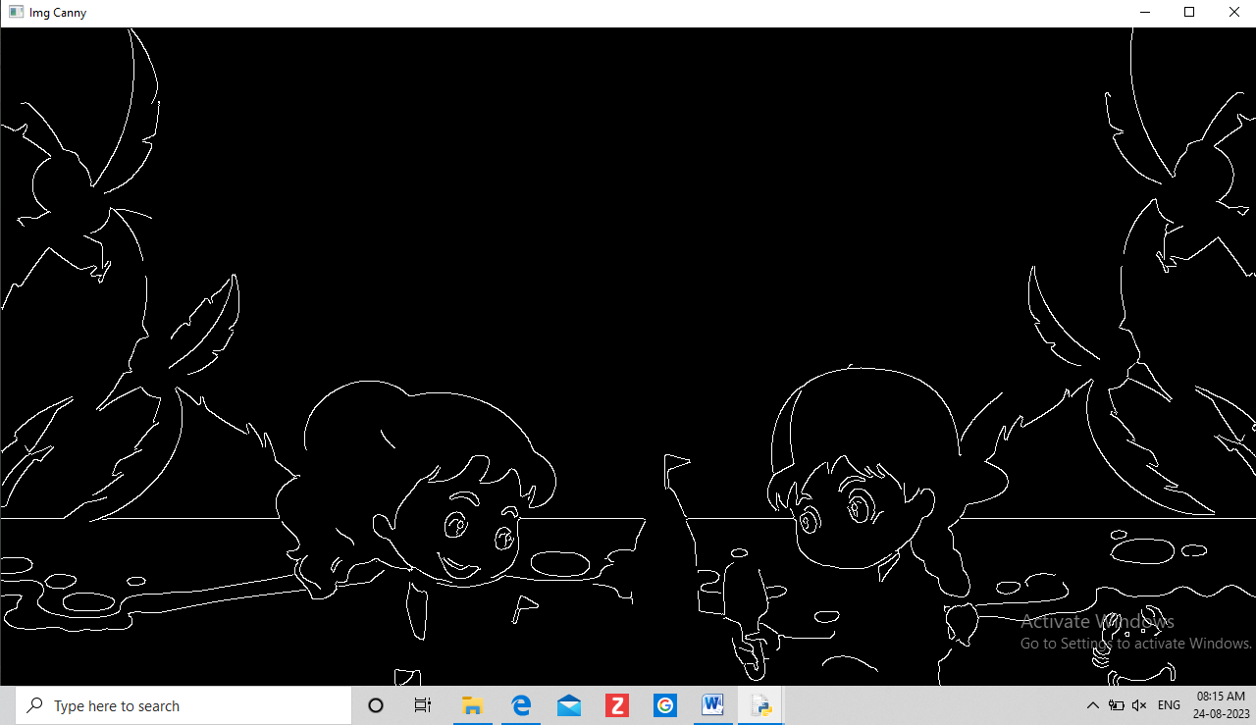

**PROGRAM 17:**

**Perform Edge detection using Sobel Matrix along X axis.**

**PROGRAM:**

**import cv2**

**img = cv2.imread("C:\Users\PADMASRI\Downloads\rose.jpeg")**

**cv2.imshow('Original', img)**

**cv2.waitKey(0)**

**img_gray = cv2.cvtColor(img, cv2.COLOR_BGR2GRAY)**

**# Blur the image for better edge detection**

**img_blur = cv2.GaussianBlur(img_gray, (3,3), 0)**

**sobelx = cv2.Sobel(src=img_blur, ddepth=cv2.CV_64F, dx=1, dy=0, ksize=5) # Sobel Edge Detection on the X axis**

**cv2.imshow('Sobel X', sobelx)**

**cv2.waitKey(0)**

**INPUT:**



**OUTPUT:**

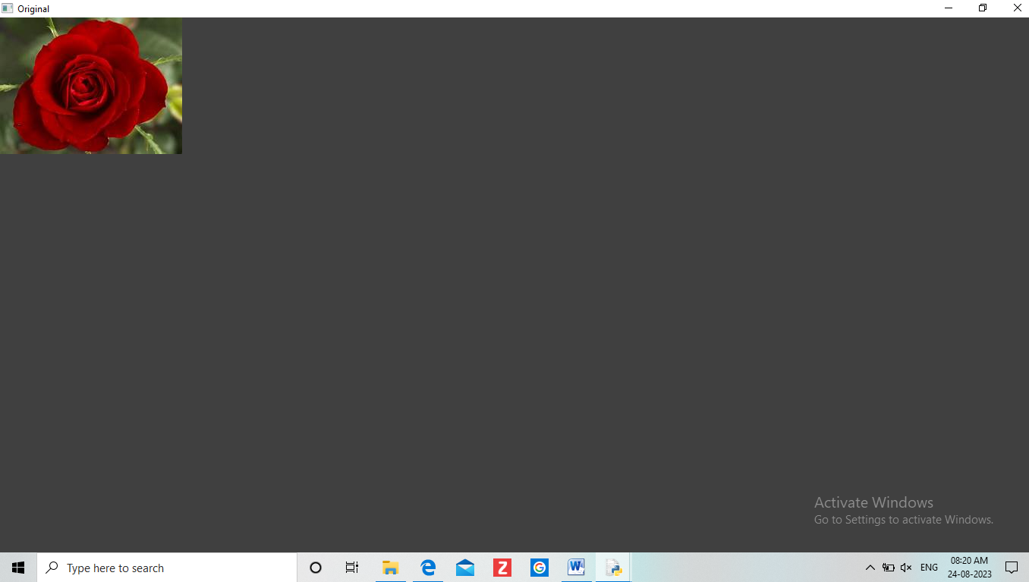

**PROGRAM 18:**

**Perform Edge detection using Sobel Matrix along Y axis.**

**PROGRAM:**

**import cv2**

**# Read the original image**

**img = cv2.imread("C:/Users/PADMASRI/Downloads/pic.jpeg")**

**# Display original image**

**cv2.imshow('Original', img)**

**cv2.waitKey(0)**

**# Convert to graycsale**

**img_gray = cv2.cvtColor(img, cv2.COLOR_BGR2GRAY)**

**# Blur the image for better edge detection**

**img_blur = cv2.GaussianBlur(img_gray, (3,3), 0)**

**# Sobel Edge Detection**

**sobely = cv2.Sobel(src=img_blur, ddepth=cv2.CV_64F, dx=0, dy=1, ksize=5) # Sobel Edge Detection on the Y axis**

**# Display Sobel Edge Detection Images**

**cv2.imshow('Sobel Y', sobely)**

**cv2.waitKey(0)**

**INPUT:**



**OUTPUT:**



**PROGRAM 19:**

**Perform Edge detection using Sobel Matrix along XY axis.**

**PROGRAM:**

**import cv2**

**img = cv2.imread("C:/Users/PADMASRI/Downloads/pic.jpeg ")**

**# Display original image**

**cv2.imshow('Original', img)**

**cv2.waitKey(0)**

**img_gray = cv2.cvtColor(img, cv2.COLOR_BGR2GRAY)**

**# Blur the image for better edge detection**

**img_blur = cv2.GaussianBlur(img_gray, (3,3), 0)**

**sobelxy = cv2.Sobel(src=img_blur, ddepth=cv2.CV_64F, dx=1, dy=1, ksize=5) # Combined X and Y Sobel Edge Detection**

**cv2.imshow('Sobel X Y using Sobel() function', sobelxy)**

**cv2.waitKey(0)**

**INPUT:**



**OUTPUT:**

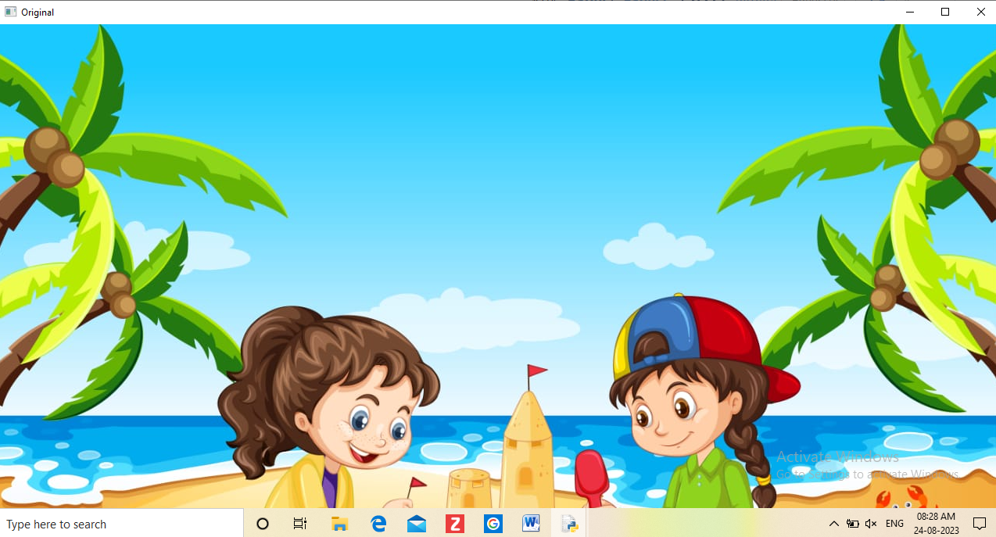

**PROGRAM 20:**

**Perform Sharpening of Image using Laplacian mask with negative center coefficient.**

**PROGRAM:**

**import cv2**

**import numpy as np**

**img = cv2.imread(r"C:/Users/PADMASRI/Downloads/pic.jpeg")**

**gray = cv2.cvtColor(img, cv2.COLOR_BGR2GRAY)**

**kernel = np.array([[0,1,0], [1,-8,1], [0,1,0]])**

**sharpened = cv2.filter2D(gray, -1, kernel)**

**cv2.imshow('Original', gray)**

**cv2.imshow('Sharpened', sharpened)**

**cv2.waitKey(0)**

**cv2.destroyAllWindows()**

**INPUT:**



**OUTPUT:**

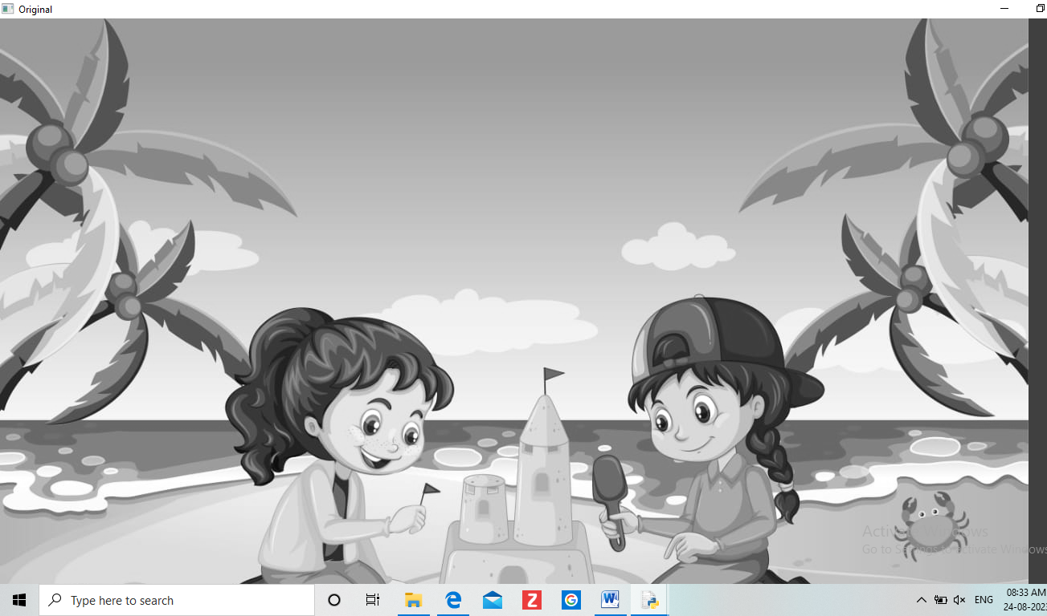

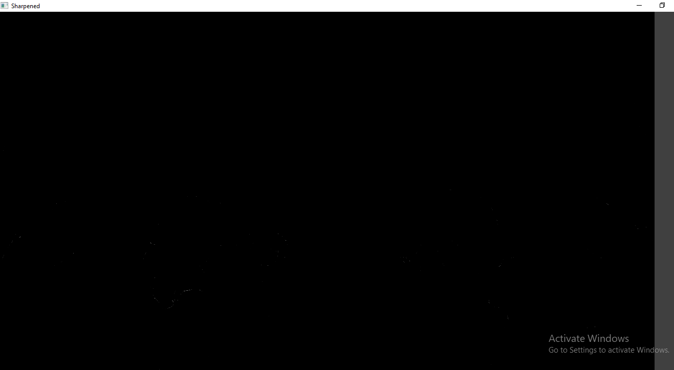

**PROGRAM 21:**

**Perform Sharpening of Image using Laplacian mask implemented with an extension of diagonal neighbors.**

**PROGRAM:**

**import cv2**

**import numpy as np**

**img = cv2.imread("C:/Users/PADMASRI/Downloads/pic.png")**

**gray = cv2.cvtColor(img, cv2.COLOR_BGR2GRAY)**

**kernel = np.array([[0,1,0], [1,-4,1], [0,1,0]])**

**sharpened = cv2.filter2D(gray, -1, kernel)**

**cv2.imshow('Original', gray)**

**cv2.imshow('Sharpened', sharpened)**

**cv2.waitKey(0)**

**cv2.destroyAllWindows()**

**INPUT:**



**OUTPUT:**

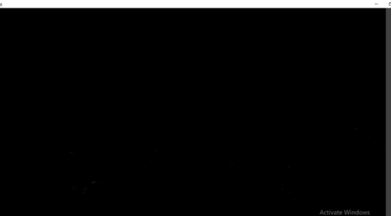

**PROGRAM 22:**

**Perform Sharpening of Image using Laplacian mask with positive center coefficient.**

**PROGRAM:**

**import cv2**

**import numpy as np**

**img = cv2.imread("C:/Users/PADMASRI/Downloads/pic.jpeg")**

**img = cv2.resize(img,(255, 255))**

**gray_img = cv2.cvtColor(img, cv2.COLOR_BGR2GRAY)**

**# Apply the Laplacian filter with a positive center coefficient**

**laplacian_kernel = np.array([[0, -1, 0], [-1, 5, -1], [0, -1, 0]])**

**sharpened_img = cv2.filter2D(gray_img, -1, laplacian_kernel)**

**sharpened_img = cv2.cvtColor(sharpened_img, cv2.COLOR_GRAY2BGR)**

**cv2.imshow('Original Image', img)**

**cv2.imshow('Sharpened Image', sharpened_img)**

**cv2.waitKey(0)**

**cv2.destroyAllWindows()**

**INPUT:**

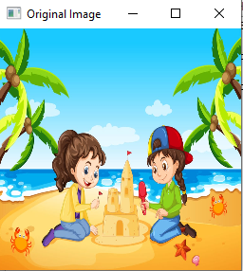

**OUTPUT:**

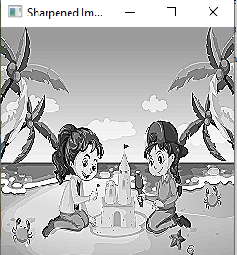

**PROGRAM 23:**

**Perform Sharpening of Image using unsharp masking.**

**PROGRAM:**

**import cv2**

**import numpy as np**

**img = cv2.imread("C:/Users/PADMASRI/Downloads/pic.jpeg")**

**gray = cv2.cvtColor(img, cv2.COLOR_BGR2GRAY)**

**laplacian_kernel = np.array([[0, 1, 0],**

**[1, -4, 1],**

**[0, 1, 0]])**

**laplacian = cv2.filter2D(gray, -1, laplacian_kernel)**

**sharpened = cv2.add(gray, laplacian)**

**cv2.imshow('Original Image', gray)**

**cv2.imshow('Sharpened Image', sharpened)**

**cv2.waitKey(0)**

**cv2.destroyAllWindows()**

**OUTPUT:**

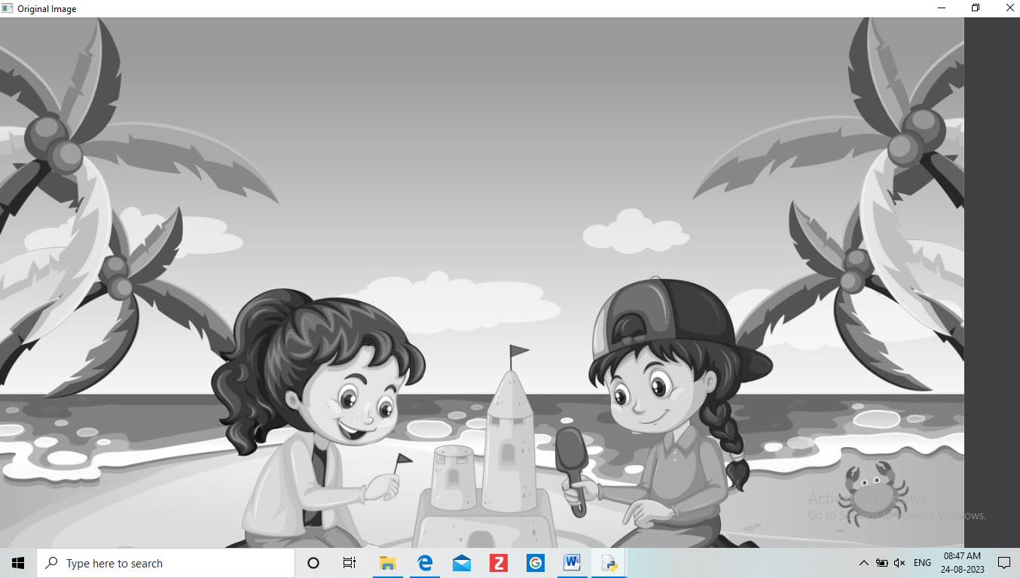

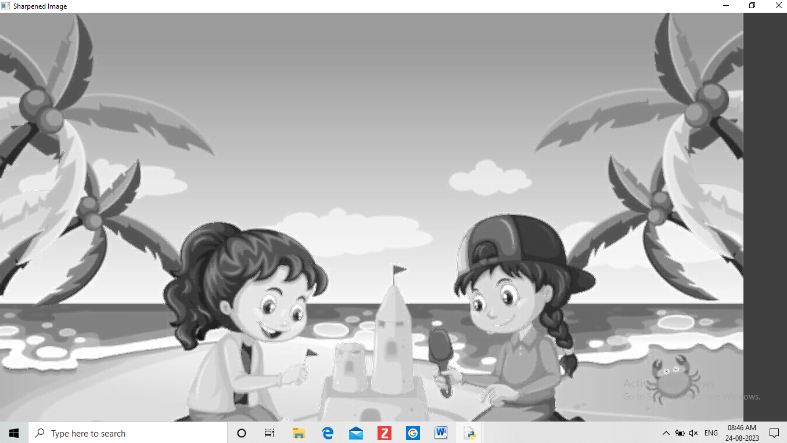

**PROGRAM 24:**

**Perform Sharpening of Image using High-Boost Masks.**

**PROGRAM:**

**h_img, w_img, _ = resized_img.shape**

**center_y = int(h_img/2)**

**center_x = int(w_img/2)**

**h_wm, w_wm, _ = resized_wm.shape**

**top_y = center_y - int(h_wm/2)**

**left_x = center_x - int(w_wm/2)**

**bottom_y = top_y + h_wm**

**right_x = left_x + w_wm**

**roi = resized_img[top_y:bottom_y, left_x:right_x]**

**result = cv2.addWeighted(roi, 1, resized_wm, 0.3, 0)**

**resized_img[top_y:bottom_y, left_x:right_x] = result**

**filename = "C:/Users/PADMASRI/Downloads/pic.jpeg"**

**cv2.imwrite(filename, resized_img)**

**cv2.imshow("Resized Input Image", resized_img)**

**cv2.waitKey(0)**

**cv2.destroyAllWindows()**

**PROGRAM 25:**

**Perform Sharpening of Image using Gradient masking**

**PROGRAM:**

**import cv2**

**a=imread("C:/Users/PADMASRI/Downloads/pic.jpeg");**

**Lap=[0, 1, 0, 1, -4, 1, 0, 1, 0];**

**a1=conv2(a,Lap,"C:/Users/PADMASRI/Downloads/pic.jpeg");**

**a2=uint8(a1);**

**imtool(abs(a-a2),[])**

**lap=[-1 ,-1, -1, -1, 8, -1, -1, -1 ,-1];**

**a3=conv2(a,lap,"C:/Users/PADMASRI/Downloads/pic.jpeg");**

**a4=uint8(a3);**

**imtool(abs(a+a4),[])**

**PROGRAM 26:**

**Insert water marking to the image using OpenCV.**

**PROGRAM:**

**import cv2**

**img = cv2.imread("C:/Users/PADMASRI/Downloads/pic.jpeg ")**

**wm = cv2.imread("C:/Users/PADMASRI/Downloads/logo.jfif")**

**h_wm, w_wm = wm.shape[:2]**

**h_img, w_img = img.shape[:2]**

**center_x = int(w_img/2)**

**center_y = int(h_img/2)**

**top_y = center_y - int(h_wm/2)**

**left_x = center_x - int(w_wm/2)**

**bottom_y = top_y + h_wm**

**right_x = left_x + w_wm**

**roi = img[top_y:bottom_y, left_x:right_x]**

**result = cv2.addWeighted(roi, 1, wm, 0.3, 0)**

**img[top_y:bottom_y, left_x:right_x] = result**

**cv2.imshow("Watermarked Image", img)**

**cv2.waitKey(0)**

**cv2.destroyAllWindows()**

**PROGRAM 27:**

**Do Cropping, Copying and pasting image inside another image using OpenCV.**

**PROGRAM:**

**import cv2**

**import numpy as np**

**image = cv2.imread(" C:/Users/PADMASRI/Downloads/pic.jpeg ")**

**img2 = cv2.imread(' C:/Users/PADMASRI/Downloads/logo.jfif')**

**print(image.shape) # Print image shape**

**cv2.imshow("original", image)**

**imageCopy = image.copy()**

**cv2.circle(imageCopy, (100, 100), 30, (255, 0, 0), -1)**

**cv2.imshow('image', image)**

**cv2.imshow('image copy', imageCopy)**

**cropped_image = image[80:280, 150:330]**

**cv2.imshow("cropped", cropped_image)**

**cv2.imwrite("Cropped Image.jpg", cropped_image)**

**dst = cv2.addWeighted(image, 0.5, img2, 0.7, 0)**

**img_arr = np.hstack((image, img2))**

**cv2.imshow('Input Images',img_arr)**

**cv2.imshow('Blended Image',dst)**

**cv2.waitKey(0)**

**cv2.destroyAllWindows()**

**PROGRAM 28:**

**Find the boundary of the image using Convolution kernel for the given image**

**PROGRAM:**

**import cv2**

**import numpy as np**

**img = cv2.imread("C:/Users/divya/PADMASRI/Downloads/pic.jpeg", cv2.IMREAD_GRAYSCALE)**

**dx = cv2.Sobel(img, cv2.CV_64F, 1, 0)**

**dy = cv2.Sobel(img, cv2.CV_64F, 0, 1)**

**edges = cv2.magnitude(dx, dy)**

**thresh = 100**

**edges[edges < thresh] = 0**

**edges[edges >= thresh] = 255**

**cv2.imshow("Edges", edges)**

**cv2.waitKey(0)**

**cv2.destroyAllWindows()**

**PROGRAM 29:**

**Morphological operations based on OpenCV using Erosion technique**

**PROGRAM:**

**import cv2**

**import numpy as np**

**img = cv2.imread("C:/Users/divya/PADMASRI/Downloads/pic.jpeg ", cv2.IMREAD_GRAYSCALE)**

**kernel = np.ones((5,5), np.uint8)**

**erosion = cv2.erode(img, kernel, iterations=1)**

**cv2.imshow("Original", img)**

**cv2.imshow("Erosion", erosion)**

**cv2.waitKey(0)**

**cv2.destroyAllWindows()**

**PROGRAM 30:**

**Morphological operations based on OpenCV using Dilation technique**

**PROGRAM:**

**import cv2**

**import numpy as np**

**img = cv2.imread("C:/Users/PADMASRI/Downloads/pic.jpeg", cv2.IMREAD_GRAYSCALE)**

**kernel = np.ones((5,5), np.uint8)**

**dilation = cv2.dilate(img, kernel, iterations=1)**

**cv2.imshow("Original", img)**

**cv2.imshow("Dilation", dilation)**

**cv2.waitKey(0)**

**cv2.destroyAllWindows()**

**PROGRAM 31:**

**Morphological operations based on OpenCV using Opening technique.**

**PROGRAM:**

**import cv2**

**import numpy as np**

**img = cv2.imread("C:/Users/PADMASRI/Downloads/pic.jpeg", cv2.IMREAD_GRAYSCALE)**

**kernel = np.ones((5,5), np.uint8)**

**opening = cv2.morphologyEx(img, cv2.MORPH_OPEN, kernel)**

**cv2.imshow("Original", img)**

**cv2.imshow("opening", opening)**

**cv2.waitKey(0)**

**cv2.destroyAllWindows()**

**PROGRAM 33:**

**Morphological operations based on OpenCV using Closing technique.**

**PROGRAM:**

**import cv2**

**import numpy as np**

**img = cv2.imread("C:/Users/PADMASRI/Downloads/pic", cv2.IMREAD_GRAYSCALE)**

**kernel = np.ones((5,5), np.uint8)**

**closing = cv2.morphologyEx(img, cv2.MORPH_CLOSE, kernel)**

**cv2.imshow("Original", img)**

**cv2.imshow("Closing", closing)**

**cv2.waitKey(0)**

**cv2.destroyAllWindows()**

**PROGRAM 34:**

**Morphological operations based on OpenCV using Morphological Gradient technique**

**PROGRAM:**

**import cv2**

**import numpy as np**

**img = cv2.imread("C:/Users/divya/OneDrive/Documents/COMPUTER VISION/Girl with a Cat.png", cv2.IMREAD_GRAYSCALE)**

**kernel = np.ones((5,5), np.uint8)**

**grad = cv2.morphologyEx(img, cv2.MORPH_GRADIENT, kernel)**

**cv2.imshow("Original", img)**

**cv2.imshow("Gradient", grad)**

**cv2.waitKey**

**PROGRAM 35:**

**Morphological operations based on OpenCV using Top hat technique.**

**PROGRAM:**

**import cv2**

**import numpy as np**

**img = cv2.imread("C:/Users/PADMASRI/Downloads/pic.jpeg", cv2.IMREAD_GRAYSCALE)**

**kernel = np.ones((5,5), np.uint8)**

**tophat = cv2.morphologyEx(img, cv2.MORPH_TOPHAT, kernel)**

**cv2.imshow("Original", img)**

**cv2.imshow("Top Hat", tophat)**

**cv2.waitKey(0)**

**cv2.destroyAllWindows()**

**PROGRAM 35:**

**Morphological operations based on OpenCV using Black hat technique.**

**PROGRAM:**

**import cv2**

**import numpy as np**

**img = cv2.imread("C:/Users/PADMASRI/Downloads/pic.jpeg ", cv2.IMREAD_GRAYSCALE)**

**kernel = np.ones((5,5), np.uint8)**

**blackhat = cv2.morphologyEx(img, cv2.MORPH_BLACKHAT, kernel)**

**cv2.imshow("Original", img)**

**cv2.imshow("Black Hat", blackhat)**

**cv2.waitKey(0)**

**cv2.destroyAllWindows()**

**PROGRAM 36:**

**Recognise watch from the given image by general Object recognition using OpenCV.**

**PROGRAM:**

**import cv2**

**watch_cascade = cv2.CascadeClassifier("C:/Users/ PADMASRI/Downloads /watch-cascade.xml")**

**img = cv2.imread("C:/Users/PADMASRI/Downloads/pic.jpg")**

**gray = cv2.cvtColor(img, cv2.COLOR_BGR2GRAY)**

**watches = watch_cascade.detectMultiScale(gray, scaleFactor=1.2, minNeighbors=5)**

**for (x, y, w, h) in watches:**

**cv2.rectangle(img, (x, y), (x + w, y + h), (0, 255, 0), 2)**

**cv2.imshow('Watches Detected', img)**

**cv2.waitKey(0)**

**cv2.destroyAllWindows()**

**PROGRAM 37:**

**Using Opencv play Video in Reverse mode**

**PROGRAM:**

**import cv2**

**cap = cv2.VideoCapture("C:/Users/PADMASRI /Downloads/birds.mp4")**

**total_frames = cap.get(cv2.CAP_PROP_FRAME_COUNT)**

**current_frame = total_frames - 1**

**while current_frame >= 0:**

**cap.set(cv2.CAP_PROP_POS_FRAMES, current_frame)**

**ret, frame = cap.read()**

**if not ret:**

**break**

**cv2.imshow('Video in Reverse', frame)**

**if cv2.waitKey(25) & 0xFF == ord('q'):**

**break**

**current_frame -= 1**

**cap.release()**

**cv2.destroyAllWindows()**

**PROGRAM 38:**

**Face Detection using Opencv**

**PROGRAM:**

**import cv2**

**img = cv2.imread("C:/Users/PADMASRI/Downloads/rose.jpeg")**

**gray = cv2.cvtColor(img, cv2.COLOR_BGR2GRAY)**

**face_cascade = cv2.CascadeClassifier("C:/Users/PADMASRI/Downloads/haarcascade_frontalface_default.xml")**

**faces = face_cascade.detectMultiScale(gray, scaleFactor=1.1, minNeighbors=5)**

**for (x, y, w, h) in faces:**

**cv2.rectangle(img, (x, y), (x + w, y + h), (0, 255, 0), 2)**

**cv2.imshow('Faces Detected', img)**

**cv2.waitKey(0)**

**cv2.destroyAllWindows()**

**PROGRAM 39:**

**Vehicle Detection in a Video frame using OpenCV**

**PROGRAM:**

**import cv2**

**car_cascade = cv2.CascadeClassifier("C:/Users/PADMASRI/Downloads/cars.xml")**

**cap = cv2.VideoCapture("C:/Users/PADMASRI/Downloads /car.mp4")**

**while True:**

**ret, frame = cap.read()**

**gray = cv2.cvtColor(frame, cv2.COLOR_BGR2GRAY)**

**cars = car_cascade.detectMultiScale(gray, 1.1, 1)**

**for (x,y,w,h) in cars:**

**cv2.rectangle(frame, (x,y), (x+w,y+h), (0,0,255), 2)**

**cv2.imshow('frame', frame)**

**if cv2.waitKey(1) & 0xFF == ord('q'):**

**break**

**cap.release()**

**cv2.destroyAllWindows()**

**PROGRAM 40:**

**Draw Rectangular shape and extract objects**

**PROGRAM:**

**import cv2**

**img = cv2.imread("C:/Users/divya/OneDrive/Documents/COMPUTER VISION/40.jpg")**

**x, y = 100, 100**

**width, height = 200, 150**

**roi = img[y:y+height, x:x+width]**

**cv2.imshow('ROI', roi)**

**cv2.waitKey(0)**

**cv2.destroyAllWindows()**